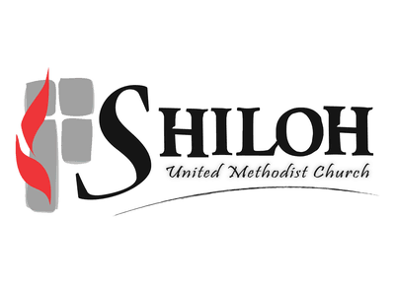
2024 Director of Youth and Young Adults Ministry Job Description

Our Mission and Vision

The mission of Shiloh United Methodist Church through the Spirit is to glorify God, develop disciples of Jesus Christ, and change the world.

Our vision is to seek and share God’s gift of oneness.

Classification: Salaried, Non-Exempt, 40 hours per week, overtime approved for mission trip.

Reports to: Lead Pastor, SPPRC (Personnel Committee)

The position of Director of Youth and Young Adult Ministry exists to lead a robust youth and young adult ministry at Shiloh United Methodist Church that aligns with the church’s mission, vision, and strategic plan. Working with volunteers, staff, and other committees, this person disciples young people into mature Christian leaders at Shiloh and/or wherever life takes them.

A good program will include a balance of the following 4 key characteristics:
- Fun – participants engage in community-building activities that are fun and invitational.
- Discipleship – participants engage in faith-building studies and activities to grow their knowledge and experience in the Christian faith.
- Mission/Outreach – participants engage in activities both inside and outside of the church to serve to learn how to be a better servant leader. This will include at least 1 mission trip experience per year for the youth participants and should include mission work with the poor.
- Fund-Raising – participants engage in raising a portion of the money needed to fund the other 3 activities as a way to teach responsibility.

Primary Job Responsibilities:
- Youth:
  - In collaboration with volunteers, develop a weekly youth ministry event that shows balances the 4 key characteristics.
  - In collaboration with volunteers, develop a weekly youth education program on Sunday morning that focuses on discipleship.
  - Lead at least 1 yearly week long mission trip for youth.
  - Find ways outside of #1 & #2 to develop the community, faith, and leadership of the young people (retreats, lock-ins, small groups, fun trips, etc).
  - In collaboration with the Lead Pastor, develop and lead a yearly Confirmation Class.
  - Implement, update, and oversee the Safe Sanctuaries Policy for youth.
  - Find other ways to connect with youth in their lives.
  - Help Shiloh develop outreach ministries that effectively connect with youth and young adults that live around the church, including students at Delhi Middle School.
- Young Adults
  - In collaboration with volunteers, develop a regular program to engage with and grow young adults in community and discipleship.
  - Help young adults connect with other ministries in the life of Shiloh.
  - Find other ways to connect with young adults in their lives.
- Family Ministries
  - Meet with the Family Ministries Committee.
  - Participate in Family Ministry events – integrating youth and young adults into family ministry events, including VBS.
  - Work with the Family Ministries Director to help with the administration of Upward Basketball during the season.

A good Director of Youth and Young Adult Ministry Director will have the following qualities:
- Be the kind of servant leader that works collaboratively with staff and nurtures volunteers to design and implement a high-quality ministry that balances the above 4 key characteristics.
- Be the kind of servant leader that leads by example, sharing their life and faith with others. This includes creatively finding ways to invest in the lives of the participants.
- Be the kind of servant leader who sees that youth and young adults need to be integrated into the entire life of the congregation – including worship – and to lead by example by sharing their time and talents with other ministries.
- Be a person of mature faith that can teach but allow room for an exploration of faith by the participants while articulating a grace-filled United Methodist theology.
- Be a good administrator who maintains good records, communicates effectively with all stake holders, and manages their time to effectively balance office hours, staff responsibilities, program events, and time to connect with the participants.

Education and Experience
2-4 years of demonstrated successful experience in student ministries
Bachelor’s degree preferred in areas of interest pertaining to student ministries
Meets all Safe Sanctuary Guidelines

Candidates can apply by emailing cover letter, resume, and references to ktomlinson@shilohumc.com

November 2024

